Davis Joint Unified School District
5th & B Street Site:
Development Concept Workshop Results
& Market Feasibility Analysis

Report to the Davis Joint Unified School District
October 2016

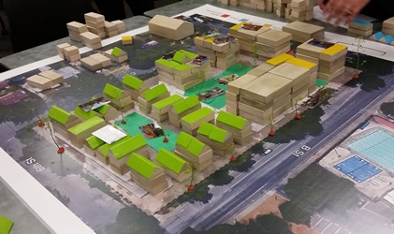

Funding and staff support from the Sacramento Area Council of Governments

Report prepared by:
Robert Liberty – Director, Urban Sustainability Accelerator
Judy Walton – Program Administrator, Urban Sustainability Accelerator
Santiago Mendez – Graduate Assistant, Urban Sustainability Accelerator
Alex Steinberger – Fregonese Associates

Acknowledgements

This project was made possible by a technical assistance grant from the State of California’s Strategic Growth Council through the Sacramento Area Council of Governments (SACOG), and with the support of many people including:

- Workshop participants and volunteers, especially UC Davis students Megan Ha, Stephanie Lau, and Michelle Byars (photographer)
- Greg Chew, Sacramento Area Council of Governments (SACOG)
- Bruce Colby, Davis Joint Unified School District
- Mike Webb, City of Davis
- Prof. Steve Wheeler, UC Davis
- Bob Wolcott, City of Davis

Cover Photo Credit: Michelle Byars

Acknowledgement
The work upon which this publication is based was funded in whole or in part through a grant awarded
by the Strategic Growth Council.
Disclaimer
The statements and conclusions of this report are those of the GRANTEE and/or Subcontractor and not necessarily those of the Strategic Growth Council or of the Department of Conservation, or its employees. The Strategic Growth Council and the Department make no warranties, express or implied, and assume no liability for the information contained in the succeeding text.

Table of Contents

Acknowledgements 3
Summary 5
Part I 7
Origins and Goals of the Project 7
Origins 7
Goals 8
Methods 9
Interviews and Visits to Davis 9
Image Library 9
Financial Feasibility Analysis 10
Community Workshops 10
Findings 13
Interesting Opinions and Perspectives from the Interviews 13
Observations about the Team Redevelopment Concepts 14
Economic Feasibility Analysis 18
Evaluation of the Utility of the Workshop Format 20
Part II 22
Workshop Results 22
Appendices 22
Appendix 1: List of Interviewees 22
Appendix 2: List of Project Team Members 23
Appendix 3: List of Workshop Participants 23
Appendix 4: Graphs, Illustrations, PPT Presentations 24

Summary

A technical assistance grant from the State of California’s Strategic Growth Council through the Sacramento Area Council of Governments (SACOG) funded a set of stakeholder interviews, workshops and financial feasibility analyses in the Spring of 2016 for potential redevelopment of the 2.2-acre property owned by the Davis Joint Unified School District (DJUSD) at 5th & B Streets in Davis. This property currently serves as the site for the DJUSD administrative offices, the Davis School of Independent Studies, adult education classes, and associated parking.

The primary conclusions derived from the workshops are:

- There is a consensus that the project site has the capacity for more intensive use than its current use, including a mix of land uses such as housing, office and commercial.

- Most or all participants agreed that the height and bulk of the buildings should be on a gradient from the lowest and smallest on the northeast corner to tallest and largest on the southern part of the property fronting 5th, especially the southwest corner at 5th and B. There was a spectrum of thoughts regarding the degree of intensity, density and massing for this site.

- All proposals included multifamily housing of some type, from town homes to multifamily apartments and condominiums.

- There was a consensus that the northern half of the property should be used just for residential uses.

- Maximum building heights ranged from 4 to 6 stories in most of the design concepts prepared by the teams.

- The primary use of the property in the redevelopment concepts, as measured by square footage, was housing – by a wide margin. The second most selected use, by square footage, was office space.

- Small amounts of retail commercial space (e.g., coffee shops) were present in many of the concepts as a way of activating the property, but none of the concepts proposed significant amounts of retail commercial development.

- The form and amount of automobile parking was the subject of great variability and uncertainty. Only one team attempted to accommodate the amount of parking currently required by city code with surface parking, which occupied the majority of the property. Others addressed it with above ground or below ground parking facilities, or by not providing the amount generated by the proposed land uses.
- Landscaping and green design elements were important in every proposal.

- Participants were curious about the possibility of moving the DJUSD administrative offices and DSIS classrooms to another site, but they did not address this in detail during the workshops due to lack of time. The relocation of those functions to another site was the subject of much discussion in the pre-workshop interviews.

The financial feasibility analysis examined three redevelopment concepts based on different approaches used by the workshop teams. Conclusions include:

- DJUSD will probably need to move its offices if it wishes to pay for the construction of replacement facilities with proceeds from the sale of its property (after DJUSD has secured the land use and planning approvals necessary for the redevelopment).

- DJUSD may be able to break even (that is, finance the purchase of a new site and build replacement facilities on them) if it maximizes development potential – within the height and bulk framework as outlined at the workshops – and sells the entire site.

- The maximum site value is achieved with the primary use of the property being residential development that is more intense than nearby residential uses.

- The maximum financial return to DJUSD is achieved when providing less parking for residential and commercial development than currently required under city regulations, and less than what the market typically delivers in Davis. It is worth noting that the consultants’ experience in other markets has demonstrated that actual demand for on-site parking often falls far below what the market supplies. This is due in large part to the pervasive belief among major lenders that ample parking is required for commercial real estate developments to be successful. This conclusion assumes the primary use of the site is for residential development that is substantially more intense than bungalows on 6,000 square foot lots, as in neighboring properties.

- There is no feasible scenario in which DJUSD can sell a portion of the site while retaining and renovating the remaining portion of its building to meet future space needs. The sale of any portion of the site will require DJUSD to engage in new construction on site, or purchase space off site.

- The off-site replacement cost for DJUSD’s administrative offices (27,000 square feet) was estimated at roughly $8-$10 million, including land. In order to recoup these costs, DJUSD would need to achieve a commensurate sales price for their land at 5th & B Streets, at $83 - $104 per square foot (roughly $8-10 million). This price premium is significantly higher than what is currently being achieved by central Davis real estate within commercial or mixed-use zones. Thus the site would have to be entitled for high intensity development in order to achieve these higher price premiums.

For reference:
Site Address | Project Name | Sale Price | Lot Size | Value/SF
901 3rd St. | Proposed Trackside | $1,489,000 | 26,572 | $56.04
2100 5th St. | Proposed  Sterling Apts. | $10,650,000 | 261,360 | $40.75
225 B St. | Mission Residences | $838,377 | 17,860 | $46.94

Part I

Origins and Goals of the Project

Origins

Yolo County and its cities have adopted strong, largely effective policies to curb urban and exurban sprawl onto the world-class agricultural land of the Sacramento Valley. However, the city of Davis, like other high-amenity university towns, has experienced substantial opposition to implementing a strategy allowing higher density residential and commercial development, a strategy that would prevent the kind of sprawl opposed by many of the same residents.

This project was designed to help the city government and its residents address the popular fears of, and regulatory barriers to more efficient, higher density growth and development that conforms to the direction of SACOG’s Blueprint Principles, and more recently to its Sustainable Communities Strategy, which addresses the intent of watershed state planning legislation, Senate Bill 375. Toward this end, we focused on a property owned by the Davis Joint Unified School District (DJUSD) immediately north of the downtown district (Figure 1 below).

Figure 1: Property owned by the Davis Joint Unified School District.

Our goal was to involve residents in producing redevelopment scenarios for the site. As a side benefit, it was hoped that the results of the project might be adapted and applied to city-owned properties downtown.

The DJUSD site - bordered by Fifth and Sixth Streets and B and C Streets - holds the District's administrative offices as well as adult learning and the Davis School for Independent Study. The facilities on the site were built as a junior high school in 1949, and are aging and out of date for current and projected administrative needs. Many of those interviewed for this project believe that, given the prime location of this site, it could be better utilized with other land uses in addition to or in place of the current school district functions.

The project team explored whether there are scenarios that could generate revenue for the District in support of students, while redeveloping the site in such a manner that enhances the community and surrounding neighborhood, and provides improved District facilities.

Any redevelopment of the property would be subject to review and approval by the City of Davis. However, the school district and the City of Davis have not held any meetings about the use of this property. Rather, the school district is taking a deliberative approach to exploring the options.

Goals

DJUSD set the following goals for the project:

Primary Goals

- Help the District to focus its resources on the educational needs of the District's students.
- Help the District provide optimal facilities for the District Office activities and the Davis School of Independent Studies.

Secondary Goal

- Help the District think of ways in which development of the property could benefit the residents of Davis and the people who work, shop, study or recreate in Davis.

Davis residents care deeply about their city, and have strong opinions about the height, bulk and design of any new development in their area, as well as concerns about the impact on surrounding properties and traffic patterns. It is important to do everything possible to ensure that any potential new development will be an asset to the community and not just a benefit to the property owner. The Urban Sustainability Accelerator was asked to listen to neighbor concerns and ideas about the property’s future.

The City of Davis had an additional goal if money and time permitted: improving the clarity and certainty of the review process for infill and compact development. Opposition to sprawl, combined with residents’ genuine concern for their quality of life, has resulted in the growth and proliferation of various plans, land use policies, and land use regulations intended to protect that quality of life. However, the number of such regulations and policies is hard to navigate and allows for varying interpretations, which increases the level of uncertainty and length of time for development.

Methods

Interviews and Visits to Davis

The School District asked Urban Sustainability Accelerator (USA) Director Robert Liberty to conduct some informal, one-on-one meetings regarding potential redevelopment of the DJUSD property with residents of the neighborhood who lived near the facility, and with others in Davis who had experiences and backgrounds that could be helpful.

USA staff (Robert Liberty and Judy Walton) conducted 25 interviews lasting 20-75 minutes each with a broad spectrum of people. Some of those interviews were held in Davis and others were by telephone. (See Appendix 1 for a list of interviewees.)

Interviewees included neighborhood association leaders, residents living across the street from the site, other residents of Old North Davis and nearby neighborhoods, real estate professionals, business organization leaders, downtown promoters, designers, UC Davis staff, Farmer’s Market staff, School District staff, and a School Board member.

USA staff made three trips to Davis, participated in walking tours of the Old North Davis neighborhood and downtown, and visited the DJUSD administrative buildings.

These visits, interviews, and discussions educated the USA team about community circumstances, concerns and hopes, and helped frame the next steps.

Image Library

USA gathered a library of images of different types of buildings and development that could serve as examples for this site (see Figure 2, below). This library was used as reference material for the site redevelopment exercise in the workshops described below.

The emphasis of the library images was on office buildings and different types of housing, from single family homes to multi-unit apartments, condominiums, senior and affordable housing. The project team also collected images of small retail and community uses (coffee shop, community kitchen) and landscaping features, such as rainwater gardens and community gardens and pocket parks.

Each library image was accompanied by information about the building or project, such as number of stories, size of the site, and location (see example in Figure 2, below).

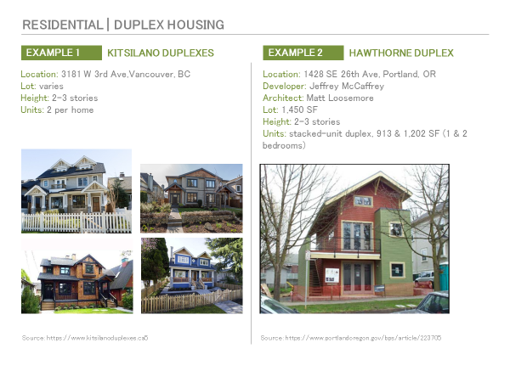
Figure 2: Example illustration from the project’s image library. Credit: Urban Sustainability Accelerator

Financial Feasibility Analysis

USA commissioned an analysis of development types that are economically feasible – that is, would generate an adequate return from the sale of land to pay for the replacement of its administrative offices and the Davis School of Independent Studies. This question involves not just building use, height, and bulk, but also the amount and type of parking.

The analysis was conducted by Alex Steinberger of Fregonese Associates (FA). Fregonese Associates provides a variety of planning services including Return on Investment (ROI) analyses. ROI analysis helps to examine financial feasibility of redevelopment.

Community Workshops

USA designed a workshop/brainstorming exercise intended to be illuminating and fun. It was not to resemble a public hearing, but rather was to be informal, faster-moving and more improvisational.

At each workshop, assigned teams made up of four or five community members used wooden building blocks and other materials to create a scale model illustrating their ideas for redevelopment of the property. The blocks were built to scale and placed on a large base map showing the site and surrounding area (see Figure 3, below).

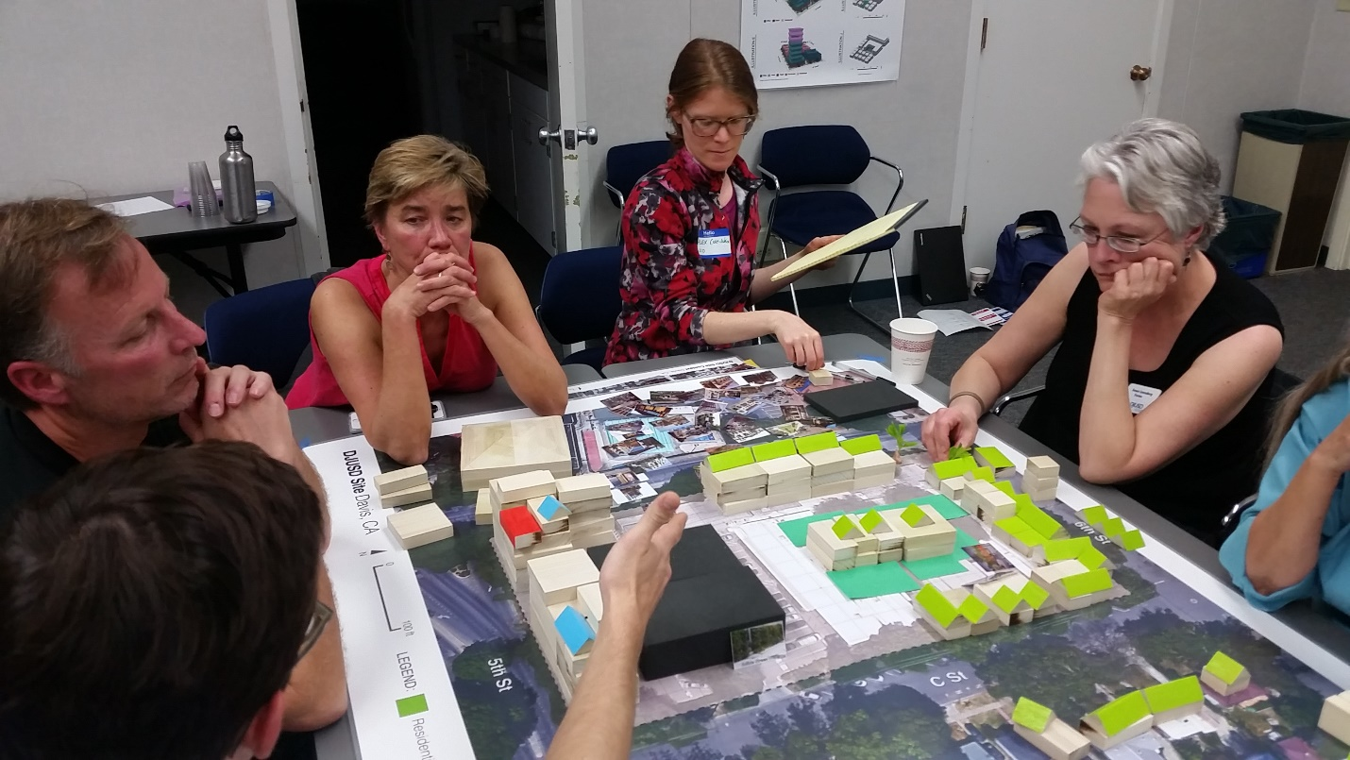
Figure 3: Table of community members at a site brainstorming workshop. Credit: Urban Sustainability Accelerator.

Design professionals and students, facilitators, and an expert in development economics were available to answer questions and help participants with the exercise.

Each session began with some background information on national and regional demographic changes, the City of Davis General Plan, some basics about real estate development economics and information about the site. In addition, the DJUSD goals for its site were presented and the nature and purpose of the exercise. The materials to be used in building the development concept and their use were explained.

The ground rules included that the teams needed to address the DJUSD’s objectives and that their designs did not have to conform to existing zoning and parking requirements. (Additional comments about the parking element of the exercise are offered below.)

The participants were provided with some background on development economics and an overview of the image library, which was made available at each table. The workshops also had volunteers, primarily UC Davis landscape architecture or community design students, to act as design assistants and facilitators.

Every session ended with each team presenting its design, explaining its reasoning and exchanging questions, responses, and observations (see Figure 4, below). Participants in each session were asked whether they thought the workshop, including the use of blocks, photos and other materials, had been useful.

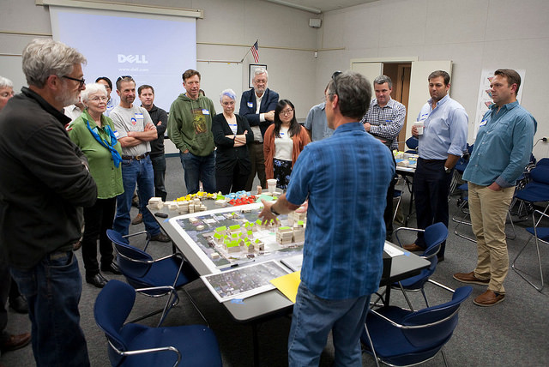
Figure 4: Participant presenting his group’s built outcome. Credit: Urban Sustainability Accelerator.

The purpose of the workshops was not to arrive at a community consensus or a
particular design, (as would be done in a charrette) but to:

• Generate redevelopment concepts that could achieve the District’s objectives.

• Find out what range of uses, densities, heights and designs would be acceptable to the teams made up of Davis residents.

• Understand neighborhood concerns.

• Collect new insights and ideas about the property.

The project team tested the workshop twice – once in Portland with PSU planning students, and once in Davis with the staffs of the City of Davis, DJUSD, SACOG and others – and made revisions as needed (see Figure 5, below).

After the test runs, a series of four workshops were held in Davis, on March 31 (3-5 pm and 7-9 pm), and April 15 (1-3 pm and 4-6 pm). Each workshop lasted about two hours, with several running over by ten to twenty minutes. Each workshop included 3 to 4 tables of 3 to 5 participants each, for a total of 14 teams and 16 outcomes (two teams added an alternative to their first outcome).

Attempts were made to include the full diversity of the Davis community – from students, renters, and low-income workers (including Davis workers who live elsewhere) to housing advocates, neighborhood advocates, business owners, homeowners from a variety of neighborhoods, developers, and other professionals.

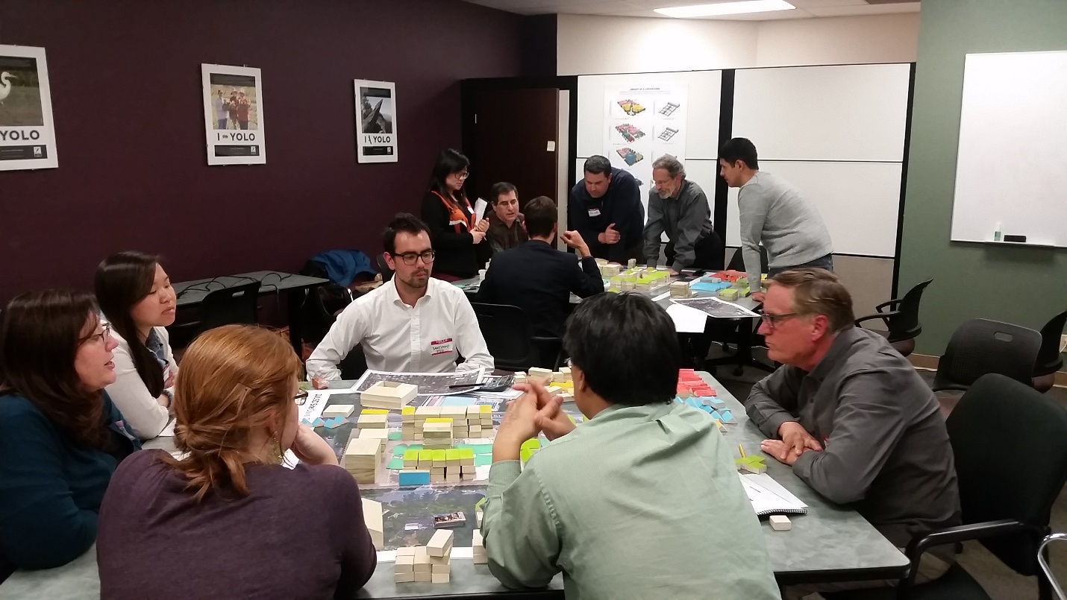
Figure 5: Test-run of the workshop with city and school district staff and a district board member. Credit: Urban Sustainability Accelerator

Findings

Interesting Opinions and Perspectives from the Interviews

The interviews, not surprisingly, reflected sharp and well known divisions of opinion on the subject of infill and redevelopment. Those are not repeated here to save space.

Less well known opinions and perspectives included the following:

- Many interviewees stressed the significance of the site as a transition from downtown, and its strategic location close to the University and at one end of Central Park. But the conclusions the interviewees drew from the site’s significance varied. Some saw it as a place to make a significant statement about the urban future of Davis, while others saw it as a place to hold the line against more commercial encroachment near the Old North Davis neighborhood.

- A few interviewees suggested that the analysis should include the city and county property to the west – as it would allow for more creative possibilities.

- There was a wider range of opinion regarding acceptable types and forms of residential development among residents of Old North Davis than what some observers from outside the neighborhood may believe. (This was confirmed by the workshops.)

- Several nearby residents and nonresidents had objections to student housing because of noise, parking issues and maintenance. Comments suggest that this is directed primarily at undergraduates.

- There was a high level of agreement, but not unanimity, that even along 5th Street the property was not a good location for retail commercial development. The reasons given were the high volume of traffic on 5th Street, which would impede pedestrian trips to retail destinations, and the undesirability of competing with downtown retail establishments. However, a substantial number believed a coffee shop might be a successful and desirable use on the site, serving City and DJUSD employees (if the District’s offices were retained) as well as residents.

- Many interviewees were unfamiliar with (or perhaps uninterested in) trends in the real estate market, which could continue shaping development pressures and patterns.

- Interviewees from the development community and broader business community believed there was a strong, pent-up market demand for almost any type of housing, from rental apartments to senior assisted living, to high-end condos, to homes for visiting UC Davis scholars.

- A small subset of interviewees believed that the demand for office space was just as great as the demand for dwellings.

- There was significant disagreement and uncertainty by participants who work in the development community on the subject of whether redevelopment would generate a high enough return to pay for structured parking of any type – belt, tuck-under or underground.

Observations about the Team Redevelopment Concepts

Building scale and massing

Every team differentiated to some extent the types of redevelopment they conceived as desired between the northern and southern ends of the property and to a lesser extent the eastern and western, with the tallest and largest buildings along 5th and C and the shortest and smallest along B and 6th (facing one-story bungalows on single family lots across the street). Some teams effectively broke the site into two, three, or four segments.

Every team’s design included at least one building of four stories or more.

Several designs included interior courtyards and greenspaces, for the residents and in some cases, for other users of the buildings.

Architecture and building design

The interviews and some of the comments by workshop team members indicated diverse architectural preferences. Some participants clearly preferred architecture that echoed or replicated designs from the era when the surrounding residential properties were developed. A few wanted at least some of the buildings on 5th to make a new and bold architectural statement, and several focused on energy-efficient design.

Overall, given the way the exercise was structured, it was not possible to draw many conclusions about architectural preferences since most participant energy was focused on the overall urban design of the property (building sizes, massing on the property, etc.).

Landscaping, green design and setbacks

A significant number of landscaping and green design elements featured in many of the concepts. Landscaping ideas took the form of gardens or small parks and also retention or replacement of street trees (see Figure 6, below).

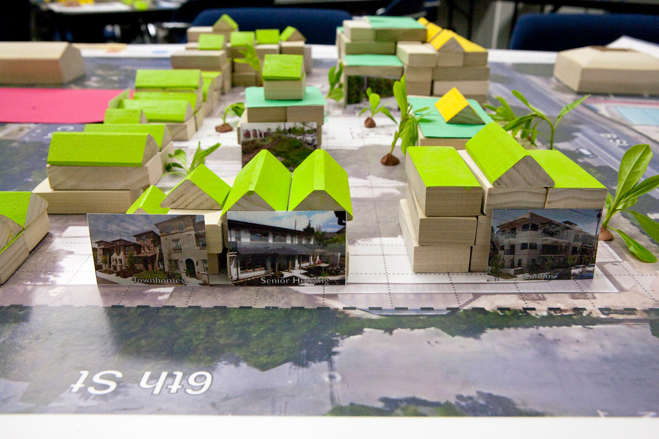
Figure 6: Street trees, green roofs and gardens were a prominent part of this group’s concept. Credit: Michelle Byars.

Green roofs, solar arrays and bioswales (vegetated basins for stormwater retention and cleansing) were the most common green design features. Other sustainability features mentioned by one or more team were passive house design (net zero energy), bicycle parking, and car sharing spaces.

Setbacks, especially along the sides of the site facing single family homes, were prominent in some of the designs. They were probably an element that would have received more attention if the teams had more time to refine their designs. (Almost all participants however, were satisfied with the length of the exercise.)

Uses and impacts

The use with the most square footage in almost all of the designs was housing. The housing in the redevelopment concepts took many forms: bungalows, accessory units, cottage homes, townhomes, duplexes and triplexes, multifamily housing, affordable multifamily housing, high-end condominiums, student housing and senior housing.

Several teams explicitly emphasized the inclusion of affordable housing as part of the project, along with market rate housing.

The second largest volume of use was dedicated to office space, including the accommodation of DJUSD offices in a new building (or buildings) on site.

The Davis School of Independent Study (DSIS) appeared in some of the designs, often combined with the DJUSD offices.

Ground floor retail showed up in several designs, usually described as a coffee shop or restaurant. This kind of use was combined with other uses – often, but not only, office use.

Other uses that were specified in the designs included:
- Hotels (boutique, extended stay)
- Live-work units
- Housing for DJUSD staff and teachers
- Community center, communal kitchen, teaching kitchen, common space, corner plaza
- Child-care facility
- Alleyways and cut-through streets
- Parks and gardens, urban orchard
- Dedicated car share spaces
- “Woonerfs” (livable neighborhood streets shared by pedestrians and calmed traffic)

Parking

Parking in the neighborhood, just as in the city center, was a concern for many residents. It is associated with their concern about increased traffic as well. Not providing sufficient parking for the redevelopment would further reduce the supply of on-street parking nearby.

Another concern was the disappearance of the current surface parking spaces for use by the Farmers Market on Saturday mornings and Wednesday evenings. USA made the assumption for the purpose of this study that redevelopment of the site should not be made contingent or dependent on supplying parking twice a week for an off-site use.

Addressing parking on the site was challenging for both the designers of the exercise and the team members. On the one hand, the ground rules allowed the team members to ignore zoning regulations, including minimum parking requirements. On the other hand, there were serious questions about whether housing or offices without parking, or with very low parking ratios (the practice in denser and more expensive cities and districts with better transit service) would be desirable to residents and tenants.

As Figure 7 below shows, the amount of parking that is included in a building can have significant implications for the rent a developer must charge to make a project feasible.

Figure 7: Relationship of parking to rental housing affordability. Credit: Alex Steinberger, Fregonese Associates.

After two trial runs and the first session, USA settled on explaining this problem to the team members – describing the wide range of parking ratios used, giving team members a rule of thumb for estimating current parking ratios required by the city, and asking them to do the best they could in indicating how much and what type of parking they would provide, and where.

Some teams struggled with this part of the assignment but others addressed the issue in their designs. Some teams referred to parking management on-site, pointing to the opportunity for complementary times for parking between office uses (day-time parking) and residential uses (night and early morning).

Both the workshops and the financial analysis showed that the provision of parking and the form of that parking play a critical role in the site design as well as financial feasibility.

Retaining or moving DJUSD facilities

Initially the USA asked some teams to redevelop the property while retaining all of the DJUSD facilities on the site – or at least the office space – while others were asked to redevelop the site without it. The last set of sessions allowed the participants to make that choice.

Ultimately it did not appear that the presence or absence of the DJUSD facilities on the site made much difference in the site designs in terms of the intensities and massing among the design concepts.

Economic Feasibility Analysis

The feasibility analysis was conducted in three phases.

The first phase involved gathering of background information on the local real estate market. Mr. Steinberger, a native of Davis with an in-depth understanding of the community, drew upon various market studies including the 2016 “UC Davis Apartment Vacancy and Rental Survey” and Cushman/Wakefield’s “Annual Davis Office and Commercial Real Estate Report” to help complete the analysis. In addition to local market studies, interviews were conducted with developers as well as local real estate professionals to better understand market conditions, construction costs, and demand patterns in Davis. Where local information was not available, third party data such as RS Means construction cost estimates were used.

The second phase of the ROI analysis involved developing building prototypes or “building blocks” in real estate pro forma language. For the purposes of this study, five building prototypes were developed based on viable product types identified in the developer interviews: small-lot single family homes, townhomes, four-story apartments, senior housing condominiums, and five-story offices over retail.

Based on the construction costs and achievable rents/sales prices for each prototype, Fregonese Associates calculated the maximum land value that each prototype project could “afford” to incorporate in its return-on-investment calculations. In real estate economics, this is often referred to as “residual land value.” Using this residual land value, FA then computed a maximum value for the site under a range of development “scenarios.”

The final phase of the ROI analysis consisted of a cost estimate for on- and off-site DJUSD office and educational space. Based on interviews with DJUSD representatives, Fregonese Associates was able to establish a rough estimate of per square foot construction costs for certain educational uses, which must meet specific requirements per State of California regulations.

Using this construction cost, FA developed an on- and off-site cost estimate for replacement of DJUSD’s administrative offices. For the purposes of this analysis, it was assumed that space for Adult and Special Education and the Davis School for Independent Study would be housed separately from the administrative office uses.

By comparing the results of phase two and three, FA was able to identify a range of possible development scenarios in which the entitlement and sale of the site at 5th and B Streets may result in a revenue neutral or revenue positive outcome for DJUSD.

The final financial feasibility analysis examined three redevelopment concepts based on different approaches used by the workshop teams:

Scenario 1: “Neighborhood-Scale Development”
- Relatively low intensity
- Development intensity responds to surrounding residential uses
- Does not include DJUSD on-site
This scenario was adapted from workshop groups who were comprised mostly of local residents. The primary goal of these residents was to preserve neighborhood character while still trying to maximize the value of the site. The focus was primarily residential with townhomes and carriage houses being the densest form of development on the north end of the site and some 3-4 story commercial uses on the portion of the site fronting 5th street. The scenario produced 38 housing units and 17,000 square feet of commercial space. The presumed residual land value of the site under this scenario was approximately $4.7 million.

Scenario 2: “Maximum ROI if DJUSD Builds On-Site”
- Higher intensity
- Employment-focused
- DJUSD remains on-site
Scenario 2 took inspiration from those workshop groups that sought to maximize site value while incorporating all or part of the school district’s future space requirements. The majority of groups who sought to include DJUSD uses focused more on employment uses and multifamily residential. In nearly all cases, groups who followed this theme focused the most intense commercial uses along the northern half of the site at heights of 4-6 stories. The southeastern portion of the site tended to be developed as 3-4 story multifamily with the western edge of the site being dedicated to lower intensity residential uses such as townhomes. The scenario produced 87 housing units and 64,000 square feet of commercial space. The presumed residual land value of the site under this scenario was approximately $6.2 million.

Scenario 3: “Maximum ROI if DJUSD Rebuilds Off-site”
- Higher intensity
- Residential-focused
- Does not include DJUSD on-site
Scenario 3 was based on workshop groups that sought to maximize the entire site without retaining DJUSD on-site. The majority of groups who sought to maximize overall site value focused more on higher density multi-family uses with some neighborhood-serving commercial uses. Groups of this type focused the most intense multifamily residential uses along the northern half of the site at heights of 4-6 stories, with the greatest intensity being placed at the intersection of 5th and B streets including ground-floor commercial. The southern half of the site tended to be programmed with 3-4 story multifamily residential units with some 2-3 story townhomes included on the southwestern portion of the site. The scenario produced 101 housing units and 3,500 square feet of commercial space. The presumed residual land value of the site under this scenario was approximately $9.4 million.

The main conclusions from the financial feasibility analysis (shown in detail in Part 3) were as follows:

- DJUSD moves its offices and pays for the construction of replacement facilities with proceeds from the sale of its property (after the property has secured the land use and planning approvals necessary for the redevelopment.)

- DJUSD may be able to break even (that is, finance the purchase of a new site and build replacement facilities on it) if it maximizes development potential – within the height and bulk framework as outlined at the workshops – and sells the entire site.

- The maximum site value is achieved when the primary use of the property is residential development that is more intense than nearby residential uses.

- Under any scenario, DJUSD will need to work in close partnership with the City of Davis to significantly increase the site’s entitlements above what is allowed by right under existing zoning.

- The maximum financial return to the District is achieved when less parking is provided for residential and commercial development than currently required under city regulations, and also less than normally provided by developers based on what owners and tenants may desire. This conclusion assumes the primary use of the site is for residential development that is substantially more intense than bungalows on 6,000 square-foot lots, as in neighboring properties.

Evaluation of the Utility of the Workshop Format

Almost all participants thought the workshop format and process was useful and engaging. They agreed the length of the exercise – two hours – was about right.

Ultimately the DJUSD, the City of Davis, other property owners, and community groups will determine how to use the information from the workshops for their planning and community engagement purposes.

The materials developed for the workshops – such as the building blocks, base aerial maps, and reference charts – have been left with the City of Davis for re-use.

Options for Next Steps

After receiving this report and answering questions, the District will consider whether and how to take the next steps.

If DJUSD intends to sell the site, it is highly recommended that it begin negotiations with the City of Davis for increased entitlements as soon as possible. The site’s value will be determined largely by the intensity of development that is allowed to occur by right.

Given the site’s importance, the District could ask for additional review and analysis of the financial feasibility conclusions. This may include assistance with entitlement negotiations, master planning, and issuance as well as management of a request for a developer interest process. The review and analysis work could be carried out by the District, by Fregonese Associates or another firm, or by gathering expert opinion from real estate and development professionals, focusing both on achievable rents and sales prices and construction costs for its facilities.

If the District is satisfied that the analysis is accurate, then it may wish to explore whether it will be able to find another suitable site to relocate its offices and the Davis School of Independent Study.

If there is such a site, the District could then make a preliminary decision about how to create an actual redevelopment proposal. Some options for next steps include a design & development competition, facilitated for example by faculty and students at UC Davis, or a competitive bidding process based on what has been learned through the USA-SACOG assistance program.

Another option suggested by workshop participants is to run the same workshop, but this time move the site to the adjacent city-owned property where City Hall and other city amenities are located. In Spring 2016, UC Davis Professor Stephen Wheeler’s Landscape Architecture 142 class developed potential redevelopment options for the City Hall block bounded by the streets of A, B, 5th and 6th.

A specific development concept would emerge from this stage.

At this point, DJUSD may wish to ask the City of Davis to carry out a preliminary review of whether or how such a development would or could satisfy the city’s General Plan, and what changes to land use regulations on the site might be required before it could be developed.

Part II

Workshop Results
- See separate document, “Part II: Workshop Redevelopment Concepts”

Appendices

Appendix 1: List of Interviewees

Interviews were conducted during a two-day site visit on Oct 14-15, 2015, and by phone.
(25 interviewees)

First | Last | Title | Organization
- Jon | Anderson | Principal | DLR Group
- Barbara | Archer | Trustee | DJUSD
- Michael | Bisch | Board President | Downtown Davis
- Christina | Blackman | CEO | Davis Chamber of Commerce
- Herman | Boschken | Professor Emeritus, Haas School of Business | San Jose State University
- Michael | Corbett | Developer, designer
- Judy | Corbett | Consultant | Former executive director, Local Government Commission
- Dennis | Dingemans | Neighbor | Old North Davis Neighborhood Association
- Jim | Frame | Owner | Frame Surveying & Mapping
- Tamiko | Gaines | Interim Board Chair | Davis Chamber of Commerce
- Laura | Juanitas | Director of Student Services | DJUSD
- Judith | Kemper | Member at Large | Old North Davis Neighborhood Association
- Randii | MacNear | Manager | Davis Farmers' Market
- John | Meyer | Advisor to City of Davis | John Meyer & Associates
- George | Parker | Director of Facilities | DJUSD
- Chuck | Roe | Founder and President | Pyramid Construction Inc.
- Mark | Rutheiser | Associate Director, Real Estate Services | UC Davis
- Stewart | Savage | Executive Director | Davis Downtown
- Bob | Segar | Assistant Vice Chancellor, Campus Planning and Community Resources | UC Davis
- Harriet | Steiner | City Attorney for Davis | Best Best & Krieger law firm
- Jason | Taormino | Board Member | Davis Chamber of Commerce
- Steve | Tracy | President | Old North Davis Neighborhood Association
- Marilyn | Underwood | Vice President | Old North Davis Neighborhood Association
- Randy | Yackzan | Co-founder | Yackzan Group
- Lynne | Yackzan | Co-founder | Yackzan Group

Appendix 2: List of Project Team Members

Greg Chew Sacramento Area Council of Governments
Bruce Colby Davis Joint Unified School District
Robert Liberty Portland State University - Urban Sustainability Accelerator
Santiago Mendez Portland State University – Urban Sustainability Accelerator
Winfred Roberson Davis Joint Unified School District
Alex Steinberger Fregonese Associates
Judy Walton Portland State University - Urban Sustainability Accelerator
Mike Webb City of Davis
Bob Wolcott City of Davis

Appendix 3: List of Workshop Participants
(65 Participants)

Alexandra Ajo | Student, UC Davis
Barbara Archer | Trustee, DJUSD
Lisa Baker | CEO, Yolo County Housing
Michael Bisch | Board President, Downtown Davis
Christina Blackman | CEO, Davis Chamber of Commerce
Herman Boschken | Professor Emeritus, School of Business, San Jose State University
Bob Bowen | Board President, US Bicycling Hall of Fame
Melody Boyer | Resident, Old North Davis
Michelle Byars | Student, UC Davis
Alex Cole-Weiss | Student, UC Davis
Michael Corbett | Planner and developer
Judy Corbett | Urban design consultant
Diana Cruz | Student, UC Davis
Warwin Davis | Student, UC Davis
Sarina Dayal | Student, UC Davis
Dennis Dingemans | Resident, Old North Davis
Cameron Erskine | Student, UC Davis
Cheryl Essex | Landscape architect and Planning Commission member, City of Davis
Enrique Fernandez | Student, UC Davis
Cathy Forkas | Owner, Davis Cabinet Co., and resident, Old East Davis
Danielle Foster | Housing and Human Services Superintendent, City of Davis
Jim Frame | Owner, Frame Surveying & Mapping
Greg Frantz | Resident, Old North Davis
Thea French | Student, UC Davis
Karen Gellen | Resident, Old North Davis
Paul Ghiglieri | Resident, Old North Davis
Mark Gidding | Resident, Old North Davis
Steve Greenfield | Vice President, Cunningham Engineering
Mark Grote | Resident, Old East Davis, and statistician, UC Davis
Larry Guenther | Owner, Guenther's Handyman Service, and Resident, Old North Davis
Bill Habicht | Pastor, Davis Community Church
Gregg Herrington | President, Yackzan Group
Bret Hewitt | Former Planning Commissioner, City of Davis, and Resident, Old North Davis
Peilin Jiang | Student, UC Davis
Judith Kemper | Resident, Old North Davis
Camille Kirk | Interim Director of Environmental Stewardship and Sustainability, UC Davis
Matt Kowta | Economics consultant and planner, Bay Area Economics
Stephanie Lau | Student, UC Davis
Angie Lopez | Staff, Community Housing Opportunities Corporation (CHOC)
Susan Lovenburg | Board Member, DJUSD
Megan Ma | Student, UC Davis
Randii MacNear | Manager, Davis Farmers' Market
Tony Martin | Resident, Old North Davis
John Meyer | John Meyer & Associates; former Davis city manager and vice chancellor, UC Davis
Gavin Pauley | Student, UC Davis
Kemble Pope | Property owner, downtown and Old North Davis
Rhonda Reed | Resident, Old East Davis
Rick Robins | Resident, Old North Davis
Chuck Roe | Founder and President, Pyramid Construction Inc.
Mark Rutheiser | Associate Director, Real Estate Services, UC Davis
Maynard Skinner | Former mayor and council member, City of Davis
Ed Smith | Downtown worker and resident, Old North Davis
Gregory Stevens | Worker, Old North Davis (Food Coop)
Steve Tracy | President, Old North Davis Neighborhood Association
Martha Tritt | Student, UC Davis
Marilyn Underwood | Vice President, Old North Davis Neighborhood Association
Steve Wheeler | Professor, UC Davis
Angela Willson | Resident, Old North Davis
Betty Woo | Architect
Valerie Wood | Resident, Old North Davis
Scott Wood | Resident, Old North Davis
Holly Wunder Stiles | Director of Housing Development, Mutual Housing
Randy Yackzan | Co-founder, Yackzan Group
Lynne Yackzan | Co-founder, Yackzan Group
Jim Zanetto | Architect

Appendix 4: Graphs, Illustrations, PPT Presentations
- See separate document, “Appendix 4.”

